Task 1: To Create Pipes, Redirect Streams, Execute Connected Commands, Close Descriptors, Synchronize Processes, Test Data Flow
Code:
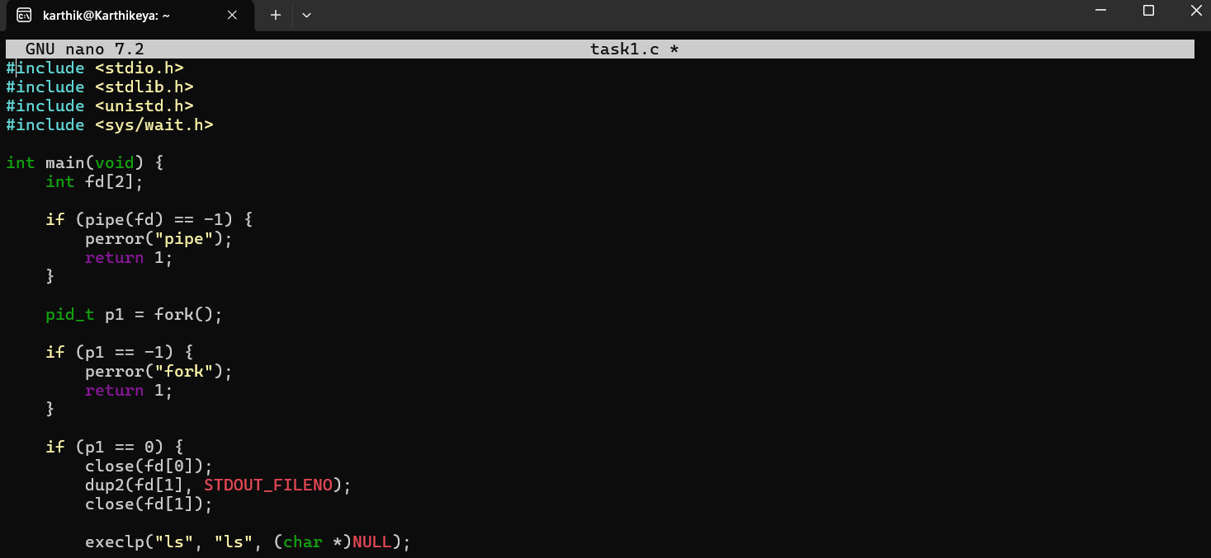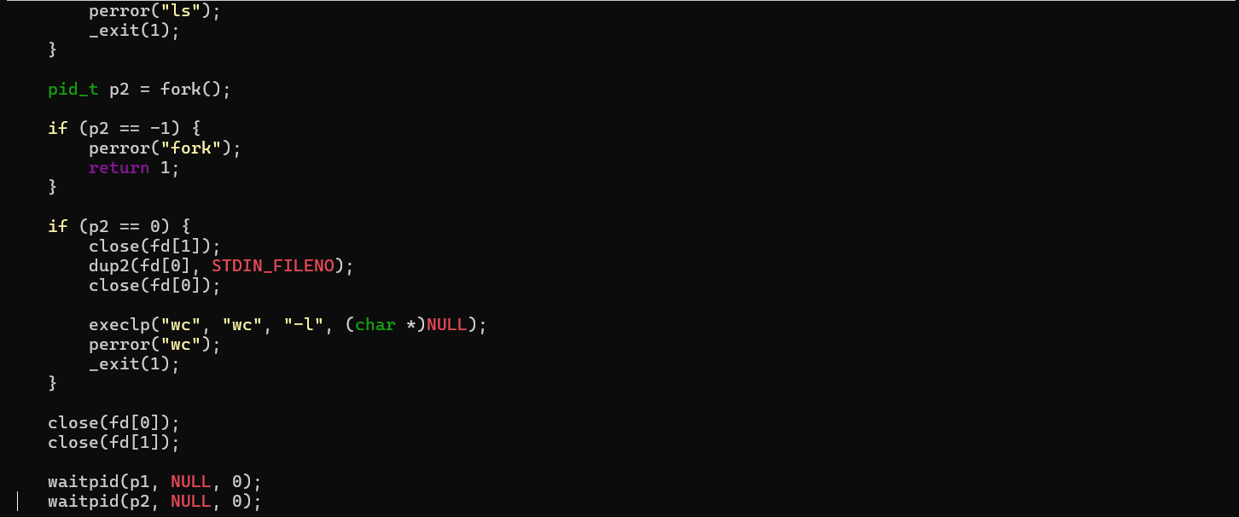

Output:
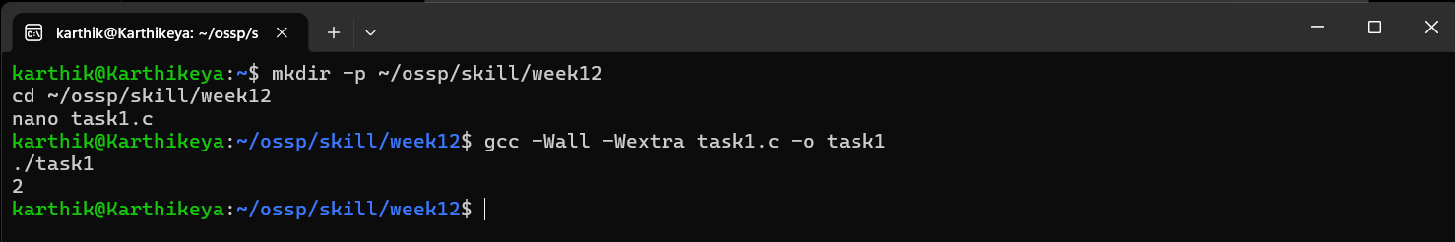

Task 2: To Support Multiple Pipes, Manage Descriptor Arrays, Launch Multiple Processes, Coordinate Execution, Cleanup Resources, Test Long Pipelines.
Code:
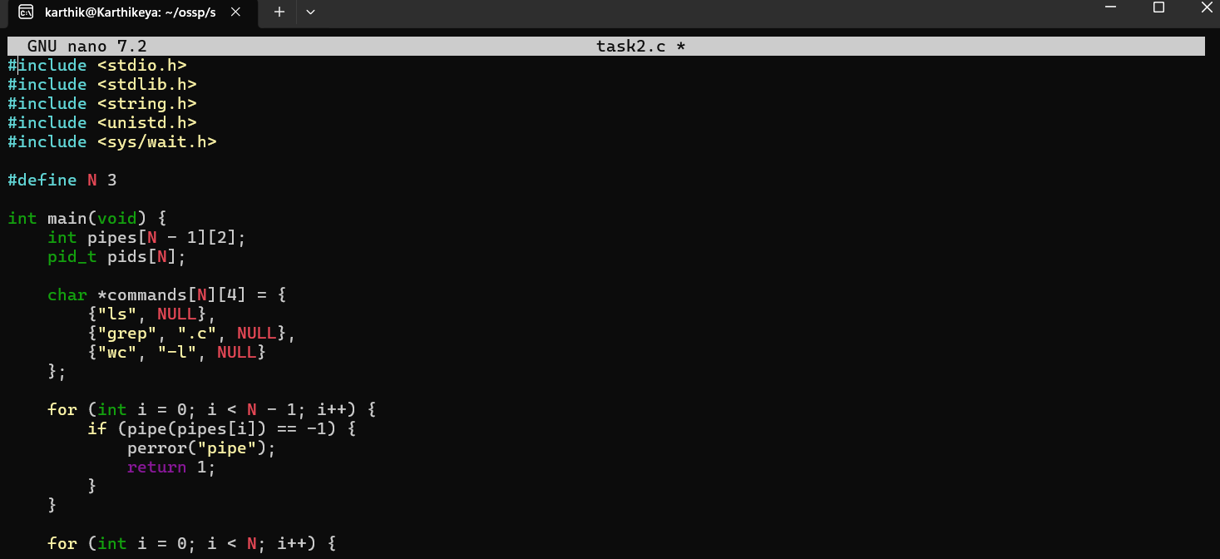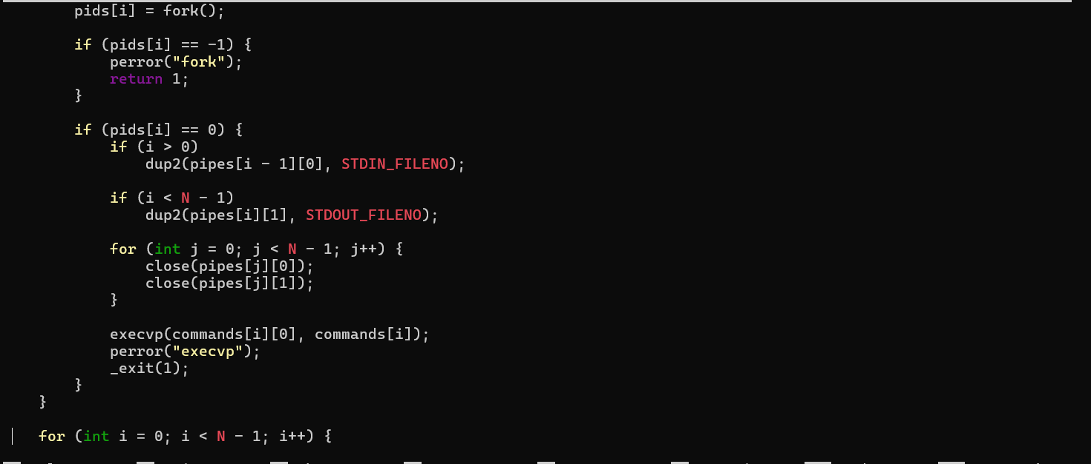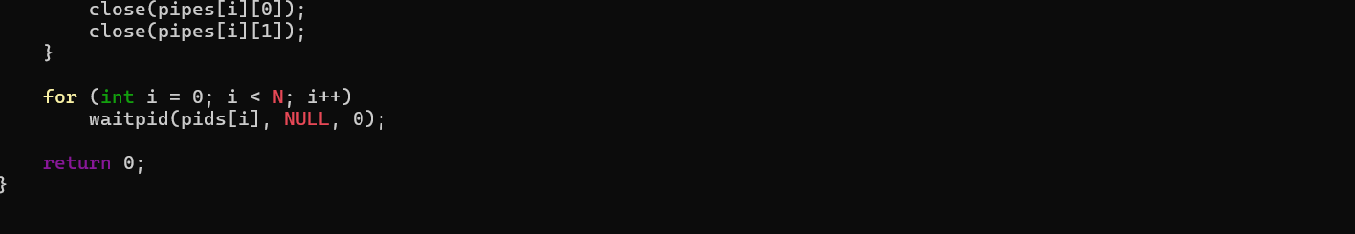

Output:
